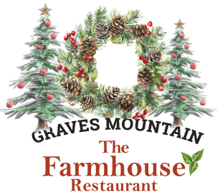
Holiday Party Menu
Lunch and Dinner
~ Your Own Event ~
Family style service at long celebration tables
Please Choose Three Family Style Entrees for your party
– passed family style by your guests.
Please ask for Gluten Free and Vegetarian Options
Appetizers - starters
- Farm Made Pimento Cheese with toast points
- Farm Baked Breads with Graves Mountain Apple Butter
- Composed Salad for Family Service
Fireplaces Crackling
Trees Sparkling
Mountains Embracing
Five Celebration Add-ons
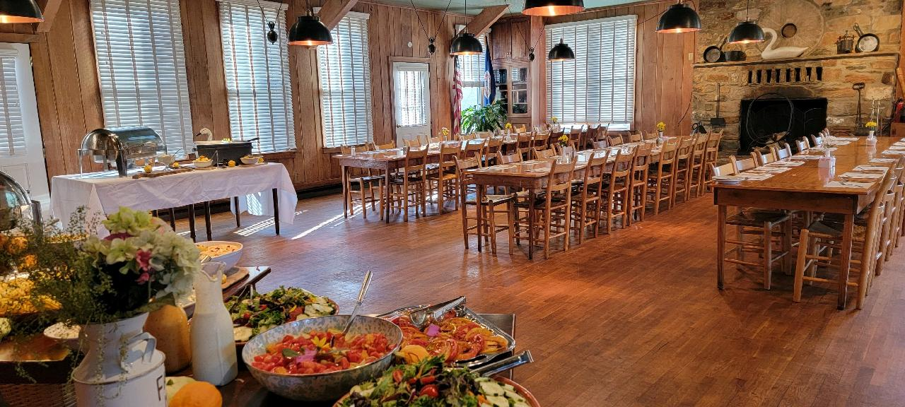
Hayride to the with warm cider to go cup $240 for up to 30 diners
30 Minute Nature Walk – depending on guide availability. $165
Santa Claus visits with you – subject to availability. $175 - donation to our Salvation Army
DuCard Wine Tasting – and talk with the wine-maker – Scott Eliff - $28 pp
Hosted Bar - consumption
Champagne Pour – DuCard Champenoise - $8
Hors d ’Oeuvres - passed and stationary
- Grits cakes – with scallion and Cranberry and Graves Mtn Red Pepper Jelly and Apple Butter accents $4 pp
- Cheese Board and Crackers – with Pimento Cream Cheese Spread $4 per person
- Graves’ Apple and Honey Ham in Pastry with Cranberry Accent $3 per piece
- Medium Chilled Shrimp - - with traditional cocktail sauce, passed – $4 per piece
- Roast Herbed Turkey over traditional sage dressing - sliced, light and dark meat. Cranberries and Cranberry sauce, of course - with baked apples
- Shrimp and Grits (GF)- Sauteed shrimp laid over top of Wades Mill stone ground organic smoky grits.
- Rose River Valley Pot Roast (GF)- Slow cooked pot roast served with red bliss potatoes and carrots .
- Smothered Chicken (GF)– Seared, sliced roast chicken topped with a heaping spoon of sauteed mushroom and caramelized onions finished with a honey mustard sauce.
- Chicken Pot Pie - Flaky pie crust stuffed with creamy chicken and vegetables.
- Vegetable Lasagna - layered fresh vegetables focused on eggplant with ricotta herb cheese layered between pasta sheets topped with mozzarella cheese.
OR
- Roast Sliced Prime Rib – with drizzled compound butter – add $5 pp
- Roast Filet of Beef with Horseradish Whipped Cream & Cranberry add $6 pp
- Fried Battered Oysters – add $6 pp
Samples of Vegetables and Sides That will come along Family Style: Corn Pudding, Broccoli and Southern Traditional Green Bean casserole, more Grits and Cheesy Scalloped Potatoes
Sample Dessert Selection - presented to the table
Ginger Cookies, Baby Brownies
$35 pp, Youth 13 to 4 Yrs Half Price – 3 and Unders Free
Including beverages, non-alcoholic. Price subject to change.
Local Wines Beers and Spirits, additional
Plus Tax and 18% Gratuity

Planning & Reservations
missy.gravesmountainsales@gmail.com
Or Melissa Whaley
Cell: 909 477 9846
melissa@gravesmountainfarm.com
Office 540 923 4231
205 Graves Mountain Lane. Syria VA

See Schedule on Following Page
Scheduling your Celebrations

Private Parties
Any Lunch or Dinner – Monday, November 25 to Sunday, December 22.
Smaller, Easy Gatherings at Restaurant Tables
Private Parties
Any Lunch or Dinner – Monday, December 1 to Sunday, December 21.
Smaller, Easy Gatherings at Restaurant Tables
Thu Dec 3 Dinner - restaurant | a La Carte Menu
Fri Dec 4 Lunch and Dinner - for restaurant gatherings
Sat Dec 5 Breakfast - with Santa, Brunch with Santa, Dinner - large buffet
Sun Dec 6 Breakfast, Brunch, No Dinner today
Thu Dec 10 Dinner - restaurant | a La Carte Menu
Fri Dec 11 Lunch and Dinner - for restaurant gatherings, get-togethers
Sat Dec 12 Breakfast - with Santa, Brunch with Santa, Dinner - large buffet
Sun Dec 13 Breakfast - with Santa, Brunch with Santa, No Dinner today
Thu Dec 17 Dinner - restaurant | a La Carte Menu
Fri Dec 18 Lunch and Dinner - for restaurant gatherings, get-togethers
Sat Dec 19 Breakfast - with Santa, Brunch with Santa, Dinner - large buffet
Sun Dec 20 Breakfast, Brunch, No Dinner today

Ladies Nights Out – Wrapping Free Zone
Join us in the restaurant for dinner and we have three special cocktails to give you a new view of the new Farmhouse Restaurant.
Thurday nights - a La Carte menu
Friday nights with a music open mic
Saturday nights with our Bluegrass Trio.
- Bourbon Egg Nog with Nutmeg Whipped Cream - $9
- Cranberry Martini $7
- Kir Royal - Raspberry Liqueur with Champagne $12
- The Candy Cane - Peppermint Schnapps and Bailey's $9
San

